VERTECO SMARTJOB

PART 3 FINAL REPORT
Final Report Updates & Refinement
Project Completion & Polishing
Deployment & CI/CD Final Status
Information Systems 3E
Work Integrated Learning
Module Code: INSY7315
Prepared for:
VERTECO
Prepared by:
Group 20 (TEAM VANTAGE)
Moegammad Alexander ST10453511 (Group Leader) Group 2
Caleb Forbes ST10438433 Group 1
Alexandro Ornelas ST10437348 Group 1
Erin Sarjoo ST10450571 Group 2
Keeran Perumal ST10367702 Group 3
Isaac Phiri ST10074970 Group 3
Submission date: 02 November 2026 (Task 3 Final Submission)
Supporting document: Final Report: System Analysis, Design and Implementation Documentation (full documentation, Tasks 1 to 3)

Contents
Group and Team Members 3
Project Links 3
About This Report 4
1 Final Report Updates & Refinement 5
1.1 Basis of the final report 5
1.2 How the documentation matches the final system 5
1.3 Final data model: planned versus built 6
1.4 Response to Task 1 feedback (Documentation and Prototype) 7
1.5 Response to Task 2 feedback (Code and Implementation) 8
1.6 Development progress since Task 2 8
2 Project Completion & Polishing 10
2.1 Completion status 10
2.2 Stability 10
2.3 Speed 11
2.4 Polish and attention to detail 12
2.5 Known limits 12
3 Deployment & CI/CD Final Status 14
3.1 Cloud environment as deployed 14
3.2 Configuration and secrets 15
3.3 CI/CD workflows 15
3.4 Deployment lifecycle 15
3.5 Database release process 17
3.6 Rollback and recovery 18
3.7 Branching and review: final status 18
3.8 Final status summary 19

Group and Team Members
Group name: Group 20 (Team Vantage)
Client: Verteco Project: SmartJob Module: Information Systems 3E, Work Integrated Learning (INSY7315)
Name and surname | Student number | Group | Main area of contribution
Moegammad Alexander (Group Leader) | ST10453511 | 2 | Project management and data lead; security, identity and notifications (authentication, JWT, lockout, password reset, notifications)
Caleb Forbes | ST10438433 | 1 | Manager web application (ASP.NET Core MVC front end)
Alexandro Ornelas | ST10437348 | 1 | Backend core: API, application, domain, infrastructure and reporting
Erin Sarjoo | ST10450571 | 2 | Mobile lead: .NET MAUI technician application
Keeran Perumal | ST10367702 | 3 | Mobile security, Android and iOS release engineering, hosting and CI/CD support
Isaac Phiri | ST10074970 | 3 | DevOps, hosting and API platform: mobile backend and offline synchronisation

Project Links
Item | Link
GitHub repository (all source code, CI/CD configuration, README) | https://github.com/EMGPRS/insy7315-2026-insy7315-2026-final-project-st10453511
Manager web application (Azure App Service) | https://verteco-smartjob-web-ctatfjduapbcdzb5.southafricanorth-01.azurewebsites.net
API liveness check | https://verteco-smartjob-api-hcdyfgf4cagdh2db.southafricanorth-01.azurewebsites.net/health/live
API readiness check (Azure SQL and Blob Storage) | https://verteco-smartjob-api-hcdyfgf4cagdh2db.southafricanorth-01.azurewebsites.net/health/ready
Video demonstration (YouTube) | https://youtu.be/Vq9oaBn_71Y
Full documentation, user guide, presentations and database script | Documents/ folder of the GitHub repository (see the README links table)

About This Report
This report is organised under three headings. The complete system documentation produced across Tasks 1 to 3 (the "Full Documentation") is submitted with it and is referred to by section number, for example "Full Documentation 22.8". The table below shows where each heading is addressed.
Section | What this report provides
1 Final Report Updates & Refinement | Every lecturer comment from Tasks 1 and 2 with the change made and where to find it; what changed in the system since Task 2; confirmation that the documentation describes the final system.
2 Project Completion & Polishing | Completion status by feature area; stability measures and evidence; measured speed; polish applied; honest list of known limits.
3 Deployment & CI/CD Final Status | The cloud environment as deployed; configuration and secrets; the five pipelines; the full deployment lifecycle with gates, health checks, release and rollback; branching status.

1 Final Report Updates & Refinement

1.1 Basis of the final report
The Full Documentation was originally submitted for Task 1 and has been carried through Tasks 2 and 3 as a single, combined document rather than as separate pieces. For the final submission it was updated in three ways: a new chapter (Full Documentation 2) that summarises all feedback and progress in one place; a targeted new subsection in each chapter where the Task 1 or Task 2 feedback pointed; and a final proofreading and formatting pass over the whole document. This report records those updates and shows how the documentation lines up with the system that is actually deployed.

1.2 How the documentation matches the final system
Aspect | Final state
Solution structure | The Full Documentation describes the same structure as the repository: an ASP.NET Core Web API and ASP.NET Core MVC web application on .NET 10, a .NET MAUI Android application, and Api, Application, Contracts, Domain, Infrastructure and Web projects with a dedicated test project.
Features | Every feature described in the Full Documentation is listed with its status in Section 2.1 of this report. Items that are intentionally out of scope for release 1 are stated openly in Section 2.5.
Hosting and pipelines | Section 3 of this report describes the deployment as built. It was checked against the five workflow files in .github/workflows/ and against the live site on 2 November 2026.
Links and files | All links are current. The README links table was updated to match the final folder names (Documents/), so every submitted document is reachable from the repository.
Database schema | The 10 Entity Framework migrations in source control define the schema. Documents/azure-sql-migration.sql is a SQL export of the first seven; the three newest (MobileSyncOperations, RetainReopenedFieldWork, AddNotifications) are applied from the EF migrations. Section 3.5 explains the process.

Where the Task 1 plan and the final build differ. The Task 1 design was written before implementation. Where the build departs from it, the difference is recorded here so that no reader is misled by the earlier plan.
Area | Task 1 plan | Final build
Authentication | JWT access tokens, rotating refresh tokens, role policies. | Delivered: email and password sign-in, 30-minute JWT access tokens, refresh tokens, lockout, password reset by email, role-based authorisation. The early development API-key header is kept for local development and Postman testing.
Cloud services | Web and API on App Service, Azure SQL, private Blob Storage, Key Vault, Application Insights, custom domain, separate UAT environment, Bicep. | Delivered and running: separate Web and API App Services, Azure SQL, private Blob Storage in South Africa North. Runtime settings are held as App Service application settings and deployment credentials as GitHub Secrets. Key Vault, Application Insights, a custom domain, a UAT environment and Bicep remain in the Full Documentation (chapters 20 and 21) as the production-hardening roadmap rather than the pilot configuration.
Mobile platforms | Android and iOS. | Android is built, signed and distributed through the pipeline. An iOS build needs macOS and Xcode and is documented in Documents/ios-build-and-release.md.
Data model | Entity relationship design in Full Documentation 13 with template versions, sections and fields. | Final database has 19 entities. Section 1.3 lists every entity and shows how each design entity maps to it.

1.3 Final data model: planned versus built
The entity relationship design in Full Documentation 13 was written at Task 1. During the build some entities were simplified and four were added for sign-in security and offline sync. The table below lists what is in the final database (the 19 entity classes in the Domain project and their 10 migrations) and how each Task 1 entity maps to it. The four added entities are also listed in Full Documentation 13.1 to 13.3.
Task 1 design entity | Final entity | What changed
USERS | User | Now holds the sign-in security fields: password hash, email confirmation, failed attempts, lockout time and suspension flag. Links to a technician through TechnicianId.
TECHNICIAN_PROFILES | Technician | Name, contact details, skills, availability and jobs completed.
CUSTOMERS, SITES | Customer, Site | As designed. A site holds its registered equipment.
JOB_CARD_TEMPLATES, TEMPLATE_VERSIONS, TEMPLATE_SECTIONS, TEMPLATE_FIELDS | JobTemplate, TemplateChecklistItem | Simplified to a template with an ordered checklist. Template versioning is not in release 1.
JOB_CARDS | JobCard | As designed, with status, priority, schedule, field notes, review and reopen reasons and flag fields.
JOB_CARD_REVISIONS | JobCardRevision | Sealed snapshot of each submission (content and content hash).
CHECKLIST_RESPONSES | JobChecklistItem | The technician's answers on a job card.
EQUIPMENT | Equipment | Equipment register per site. Equipment recorded in the field is also stored on the job card.
EVIDENCE, SIGNATURES | JobEvidence, JobSignature | Metadata and references only. The files are held in private Blob Storage.
FLAGGED_ITEMS, CORRECTIVE_ACTIONS | Flag fields on JobCard, CorrectiveAction | A flag is recorded on the job card (flagged, reason, time). Each flag has a corrective-action record with reason, open and resolved details and resolution notes.
NOTIFICATIONS, AUDIT_LOGS | Notification, AuditLog | As designed. Notifications now carry a read flag that drives the unread count.
Not in the Task 1 design | RefreshToken | Added for refresh-token sign-in: hashed token, expiry, revocation and replacement.
Not in the Task 1 design | PasswordResetToken | Added for password reset by email: hashed token, expiry and used time.
Not in the Task 1 design | MobileSyncOperation | Added for offline sync: records each processed operation so a retried upload is not applied twice.
Not in the Task 1 design | MobileSyncChange | Added for offline sync: records which job changed and when, so the app can pull only what changed.

1.4 Response to Task 1 feedback (Documentation and Prototype)
Task 1 Documentation scored 240/280 and the Prototype 83/100, both Level 4. The team did not rewrite sections that already met the standard. It concentrated on each criterion where the feedback or score showed room to improve.
Criterion (mark) | Feedback | Update made | Where
Requirements: Work Breakdown Structure (11/15) | "Mention a team member assigned to a task." | New subsection naming the member responsible for each phase of work across Task 1, Task 2 and Task 3. | Full Documentation 7.2
Requirements: UX Journey Map (7/10) | "Include screens from your prototype." | Screens from the delivered manager web application and the technician mobile application were added in support of each journey. | Full Documentation 6.3 and 6.4
Change Management (14/20) | No written comment. The score left room to improve training, handover and support detail. | New subsection with a concrete training plan, a completed handover package description and a defined post-implementation support window. | Full Documentation 25.9
Security (22/25) | No written comment. The score left room to show a mitigation for every identified risk. | New subsection mapping each identified risk to the control now live in the system (password hashing, lockout, rate limiting, JWT, role checks, security headers, audit events). | Full Documentation 22.8
Architecture: patterns and cloud architecture (8/10 each) | No written comment. The scores left room for diagrams showing how the design works and fuller service detail. | The as-built cloud architecture, service table, configuration and secrets handling, and the deployment lifecycle diagram are added in this report. | Sections 3.1 to 3.4 below
Prototype (83/100): usability, responsive design, visual consistency | No written comment. The score left room to improve usability, responsive design and visual consistency. | The prototype was replaced by the working applications and refined: multi-photo evidence capture, a live unread count on the notification bell, original Verteco icon and splash screen. | Section 1.6 below; Full Documentation 2.4

1.5 Response to Task 2 feedback (Code and Implementation)
Task 2 scored 173/210 (Level 4). Front End, Back End and Hosting were strong. The two lower criteria were both in the GitHub section. The team asked the lecturer what was missing and was told that "this part needs to be added to a Report (Document) and discussed." That is done in Section 3 of this report and in Full Documentation 23.5.
Criterion (mark) | What was added | Where
GitHub Branching & Workflow (7/15) | The branching and pull-request workflow actually used, the evidence from Task 2 (sixteen pull-request and branch-merge commits), branch protection, and an honest account of where the team committed directly to main late in Task 3, with the agreed correction. | Section 3.7; Full Documentation 23.5
GitHub CI/CD & Pipelines (9/20) | All five GitHub Actions workflows described with triggers, gates and outcomes; the complete deployment lifecycle from branch to verified release; secrets handling; health-check gating; rollback. | Sections 3.3, 3.4 and 3.6; Full Documentation 23.5
Front End, Back End, Hosting | Maintained and extended; see the development progress below. | Section 1.6

1.6 Development progress since Task 2
Area | What changed | Evidence in the repository
Evidence capture | Technicians can add more than one photograph per visit instead of being sent on after a single photo. | Mobile Photo Capture screen; private Blob Storage adapter
Offline synchronisation | Offline queue, delta pull on reconnect, idempotent push processing and row-version conflict detection implemented end to end between the app and the API. | Migrations MobileSyncOperations, MobileSyncDeltaPull, RetainReopenedFieldWork; Mobile/MobileSyncController
In-app notifications | The Notifications screen is backed by a persisted entity. The bell shows a live unread count that drops as items are read. | Migration AddNotifications; MobileNotificationsController
Identity, security and audit | Real email and password sign-in, JWT access tokens with refresh tokens, lockout after five failed attempts (15 minutes), password reset by email, role-based authorisation, security headers and a Content Security Policy, audit events for sign-in and reset activity. | Migrations AddUserIdentityFields, AddPasswordResetTokens, AddRefreshTokens; AuthController
AI report analysis | Gemini-based management analysis on the Reports page, built from the report statistics (created and completed counts, average completion time, status breakdown, flagged and high-priority jobs). It only advises. If Gemini has no key, is rate limited or cannot respond, the report shows a clear AI status and the statistics, CSV and PDF exports stay available. | Infrastructure/Ai: GeminiReportingAiService, FallbackReportingAiService
Flagged jobs and corrective actions | Managers can flag jobs and track corrective actions. | Migration FlaggedJobsAndCorrectiveActions; CorrectiveActionsController
API tooling | Swagger documentation and a 38-request Postman collection, plus a mobile API collection. | postman/ folder
Branding | The default template icon and splash screen were replaced with an original Verteco mark. | SmartJobMobile resources
Hosting and CI/CD | Automatic deployment to Azure App Service on every push to main, gated by the full test run; signed Android APK pipeline. | Section 3; .github/workflows/

2 Project Completion & Polishing

2.1 Completion status
The table lists each feature area of SmartJob, whether it is complete in the delivered system, and what the area covers. The few items that are deliberately limited are listed in Section 2.5.
Feature area | Status | What is delivered
Manager web application | Complete | Job-card creation, assignment, review and approval; dashboard; customer, site and technician management; user administration; job templates; reports; audit trail.
Technician mobile application (Android) | Complete | Secure sign-in, assigned jobs, checklist completion, multi-photo evidence, signature capture, offline working, in-app notifications.
Web API | Complete | 12 web controllers and 3 mobile controllers (jobs, notifications, sync), Swagger documentation, Postman collections, health endpoints.
Identity and security | Complete | Hashed passwords, JWT with refresh tokens, lockout, password reset, role-based access, rate limiting, security headers, audit events.
Offline synchronisation | Complete | Local queue, idempotent push, delta pull, row-version conflict handling.
Notifications | Complete | Persisted in-app notifications with unread count, and email notifications through SMTP.
AI report analysis | Complete | Gemini analysis of the report statistics with a clear status when unavailable; advisory only.
Data and storage | Complete | Azure SQL with 10 EF Core migrations; private Azure Blob Storage for evidence and signatures.
Hosting and delivery | Complete | Web and API live on Azure App Service; five GitHub Actions workflows; signed Android APK produced by the pipeline.

2.2 Stability
Stability in SmartJob comes from controls built into the code, controls in the pipeline, and checks on the live site. Each control below is present in the repository.
Control | How it protects stability | Where
Automated test suite | 63 automated tests (domain, application, infrastructure and API integration) run against an isolated in-memory database and pass. | tests/VertecoSmartJob.Tests; All Tests workflow
Quality gate on every change | Static analysis at error severity, a Release build and the tests must succeed before a pull request can merge. | SmartJob CI workflow
Fail-fast production configuration | In production the API refuses to start if the Azure SQL connection string, a JWT signing key of at least 32 characters, secure non-local HTTPS addresses or the allowed web origins are missing or invalid. A bad configuration is caught at startup instead of failing a user. | ValidateProductionConfiguration in the API
Liveness and readiness probes | /health/live confirms the process is up. /health/ready also checks access to Azure SQL and Blob Storage. The deployment waits for these to pass. | API and web health endpoints
Safe offline sync | Idempotent push means a retried upload cannot create duplicates; row versions detect two people editing the same item; delta pull sends only what changed. | Mobile sync controller and migrations
Graceful degradation | If Gemini is unavailable or rate limited, the report shows a clear AI status and the statistics and exports stay available. AI output is advisory and never approves or rejects a job (FR-74, FR-75). | GeminiReportingAiService, FallbackReportingAiService
Abuse protection | Rate limits: sign-in 10 requests per 5 minutes, AI 20 per minute, evidence uploads 10 per minute. Account lockout for 15 minutes after five failed sign-ins. | API Program.cs; AuthController
Audit trail | Sign-in, lockout, password reset and job-lifecycle events are recorded, which makes faults and misuse traceable. | Audit log and AuditController
Safe releases | A failed test run stops the deployment; deployments cannot overlap; the API must report ready before the web application is released. | Main Deploy workflow (Section 3)

Live check on 2 November 2026. Ten consecutive requests to each health endpoint of the hosted system returned HTTP 200 every time, with no failures, errors or timeouts once the application was running.

2.3 Speed
The non-functional requirements (NFR-01 and NFR-02 in the Full Documentation) set a target of about three seconds for ordinary web and mobile requests and for searching or filtering job cards. The table shows measured response times for the hosted system.
Request | Result | Response time | Samples
API /health/live | HTTP 200 | 1.03 to 1.35 s | 10
API /health/ready (checks Azure SQL and Blob) | HTTP 200 | 1.03 to 1.15 s | 10
Web /health/live | HTTP 200 | 1.01 to 1.19 s | 10
Web sign-in page /Account/Login | HTTP 200 | 1.02 to 1.22 s | 5
Web home page / | HTTP 302 (redirect to sign-in) | 1.1 to 1.3 s | 5
Table: warm response times measured on 2 November 2026 with read-only GET requests from a remote test machine. The figures include the network round trip, so users in South Africa should see equal or better times. An earlier run the same day saw the home-page redirect take up to 2.5 s.
Every warm request is inside the three-second target. Several design choices keep the system fast as data grows:
- Delta pull. The mobile app downloads only what has changed since its last sync instead of the whole job list.
- Paged queries. Job-card, corrective-action and notification lists are returned in pages (job-card pages are capped at 200 items), so lists stay quick as records accumulate.
- Evidence kept out of the database. Photographs and signatures live in Azure Blob Storage, and the database holds only their metadata.
- Optional AI. AI analysis is a separate, rate-limited call on the Reports page, so a slow external service never slows the job-card workflow.
Cold start after idle. On 2 November 2026 the first request after a quiet period was slower: the API liveness check took 3.5 s, and the first readiness check took 32 s (an earlier attempt timed out at 15 s) before everything returned to about one second. This is consistent with a hosted app waking from idle and the Azure SQL database resuming, and it is the one case that exceeds the three-second target. The recommended mitigation for production is the App Service "Always On" setting on a tier that supports it, or a scheduled keep-warm request, and it is recorded as a known limit in Section 2.5.

2.4 Polish and attention to detail
- Branding. The mobile icon and splash screen use an original Verteco mark instead of the default template graphics.
- Feedback inside the app. The notification bell shows a live, correct unread count, and marking an item as read updates it immediately.
- Evidence workflow. Multiple photographs can be taken in one visit without being forced to the next screen.
- Safer sign-in experience. Clear lockout and password-reset flows with email delivery, and security headers on both the web application and the API.
- Clean build. The solution builds in Release configuration with analyzers enforced at error level, so warnings do not accumulate.
- Documentation and repository. One consolidated document, a README whose links match the final folders, a user guide and API collections.

2.5 Known limits
The team lists these limits so that the submission can be judged on what is really there.
Limit | Position
Cold start after idle | First request after a quiet period can take 30 seconds or more. Mitigation: Always On or a keep-warm request when the app moves from pilot to production tier.
iOS | The iOS app needs a Mac with Xcode to build. The procedure is documented, but the delivered, signed build is Android.
SafetyCulture | Release 1 does not synchronise with SafetyCulture by design; existing SafetyCulture job cards remain read-only history (Full Documentation 3.15 and 20.3).
Corrective actions | Tracking is deliberately kept simple in this release.
Content Security Policy | The web policy still allows inline scripts and styles used by the MVC views. Moving to nonces is the next hardening step.
Production hardening | Key Vault, Application Insights, a custom domain, a UAT environment and infrastructure-as-code are planned for production rollout (Full Documentation 20, 21 and 24) and are not part of the pilot configuration.

3 Deployment & CI/CD Final Status

3.1 Cloud environment as deployed
SmartJob runs on Microsoft Azure in the South Africa North region. The web application and the API are separate App Services, so each can be deployed, scaled and restarted on its own. Both clients reach the data only through the API.
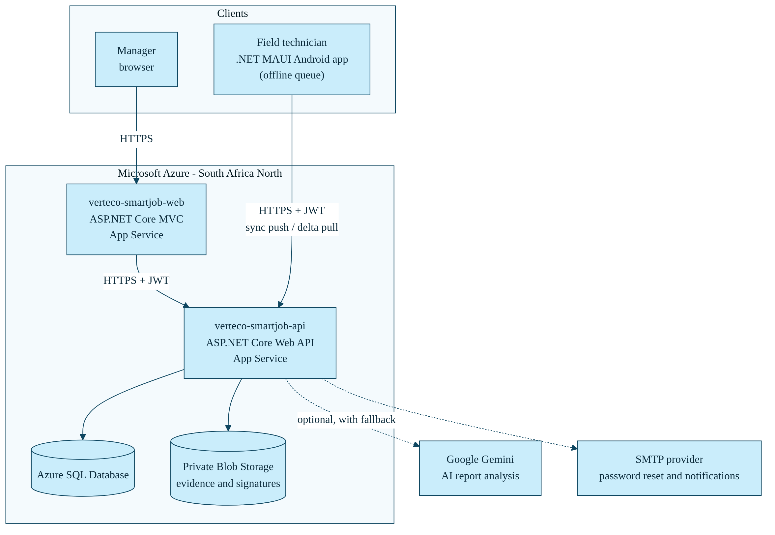
Figure 1: SmartJob cloud environment as deployed.
Component | Platform | Role and status
Manager web application | Azure App Service verteco-smartjob-web | ASP.NET Core MVC console for managers. Live. Health: /health/live.
API | Azure App Service verteco-smartjob-api | ASP.NET Core Web API shared by the web and mobile clients. Live. Health: /health/live and /health/ready.
Database | Azure SQL Database | All users, jobs, templates, sync records and audit events. Schema defined by 10 EF Core migrations.
Evidence storage | Azure Blob Storage (private) | Photographs and signatures. Never exposed directly to browsers or phones.
AI service | Google Gemini (external) | Optional report analysis. Reports and exports work without it.
Email | SMTP provider | Password reset and notification emails.
Source and pipelines | GitHub and GitHub Actions | Source control, pull-request checks, deployment and Android build.

3.2 Configuration and secrets
No secret is stored in source code, in the workflow files or inside the Android package. Three layers hold configuration:
Layer | What it holds
GitHub Secrets | AZURE_API_PUBLISH_PROFILE and AZURE_WEB_PUBLISH_PROFILE (deployment credentials for the two App Services) and ANDROID_KEYSTORE_BASE64, ANDROID_KEYSTORE_PASSWORD, ANDROID_KEY_ALIAS and ANDROID_KEY_PASSWORD (Android signing).
App Service application settings | Azure SQL connection string, Blob, SMTP and Gemini settings, plus the JWT signing key and allowed web origins that production validation requires.
Startup validation | In production the API checks that the required settings exist and are safe (see Section 2.2) and stops if they do not.

3.3 CI/CD workflows
Five GitHub Actions workflows make up the pipeline. They are stored in .github/workflows/.
Workflow | Trigger | What it does | Outcome
SmartJob CI (ci.yml) | Pull request or push to main or develop | Restores the .NET 10 solution, enforces analyzers at error severity, builds in Release and runs the test project (15-minute limit). | Pull request cannot merge on failure
SmartJob All Tests (unit-tests.yml) | Pull request or push to main or develop; manual run | Runs the whole test suite with no filter, collects TRX results and code coverage and uploads them even when a test fails (20-minute limit). | Evidence kept for every run
SmartJob Main Tests (main-tests.yml) | Called by Main Deploy; manual run | Re-runs the build and test gate on the exact commit about to be released (20-minute limit). | Blocks deployment on failure
SmartJob Main Deploy (main-deploy.yml) | Push to main | Calls Main Tests; publishes API and web; deploys the API; waits for /health/ready; deploys the web application; waits for /health/live (30-minute limit). | Release only if every step passes
SmartJob Android Build (android.yml) | Pull request or push to main or develop | Builds an unsigned APK for pull requests (so no signing secrets are exposed) and a signed release APK on push, kept as a 14-day artifact. | Installable build for each change

3.4 Deployment lifecycle
The table below and Figure 2 document every step from a developer's change to a verified release, including what happens when a step fails.
Step | Stage | Control | If it fails
1 | Feature branch and pull request | Every change is made on a short-lived branch and submitted as a pull request to main. | Not permitted by policy; see Section 3.7 for the late-stage exceptions.
2 | Pull-request checks | SmartJob CI, All Tests and Android Build run automatically. | Red check stops the merge.
3 | Review and branch protection | A reviewer must approve and the checks must pass. During Task 2 an administrator approved every merge into main. | Merge not allowed.
4 | Merge to main | The merge triggers Main Deploy and the signed Android build. | Not applicable.
5 | Main Tests gate | Build and tests run again on the exact commit being released. | Deployment stops; nothing reaches Azure.
6 | Publish | The API and web projects are published separately. | Workflow fails; nothing reaches Azure.
7 | Deploy API | Published with azure/webapps-deploy@v3 using the API publish profile secret. | Workflow fails; web not touched.
8 | API readiness check | The pipeline calls /health/ready up to 12 times, 10 seconds apart, so a slow start is tolerated. | Workflow fails; web application is not deployed.
9 | Deploy web | Published with the web publish profile secret. | Workflow fails.
10 | Web health check | The pipeline polls the web /health/live endpoint. | Workflow fails and the team investigates.
11 | Release verified | Both applications are live and healthy. | Not applicable.

The Android build also runs for the push to main and produces a signed APK as a downloadable Actions artifact. Publishing that APK as a GitHub Release is a separate manual step, and the signed APK is also embedded in the user guide for installation.
Two further controls apply to the whole lifecycle. A concurrency group (smartjob-main-deploy) means two deployments never run at the same time, and a running deployment is not cancelled halfway. Each job also has a time limit so a hung step cannot block the pipeline.
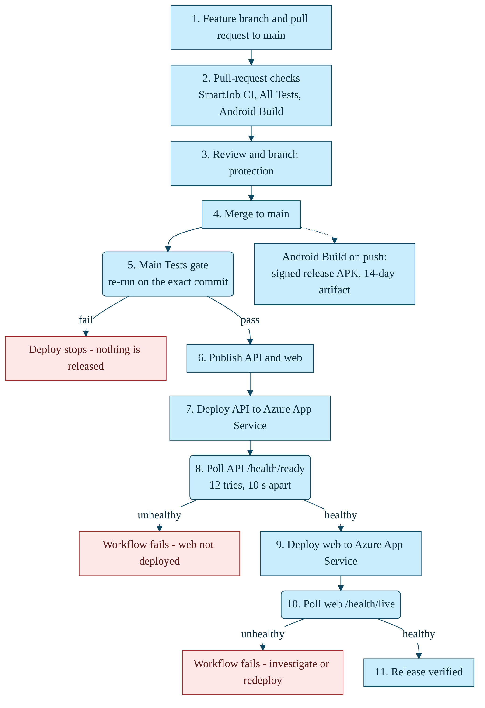
Figure 2: SmartJob deployment lifecycle, from feature branch to verified release.

3.5 Database release process
The database schema is defined by 10 Entity Framework migrations in source control: InitialAzureSql, FlaggedJobsAndCorrectiveActions, MobileSyncOperations, AddUserIdentityFields, AddPasswordResetTokens, AddStandardJobCardTemplate, MobileSyncDeltaPull, AddRefreshTokens, RetainReopenedFieldWork and AddNotifications.
- Migrations apply automatically only in Development and Testing. In production the schema is changed deliberately, so a hosted instance never alters the database on its own.
- The EF migrations in source control are the source of truth. Documents/azure-sql-migration.sql is a SQL export of the first seven; the three newest migrations (MobileSyncOperations, RetainReopenedFieldWork and AddNotifications) are applied from the EF migrations (dotnet ef database update) rather than from that file.
- Release rule going forward: when a release includes a new migration, it is applied to Azure SQL before the API is deployed, and migrations are written to stay compatible with the previous API version. Regenerating the SQL export with dotnet ef migrations script --idempotent keeps the file in step with the migrations.

3.6 Rollback and recovery
Layer | Approach
Application | Revert the faulty commit through a pull request. The merge runs the same gated pipeline and redeploys the last good code. The pipeline does not roll back by itself: a failed health check fails the workflow and alerts the team, and the unhealthy site is then fixed forward or reverted.
Database | Migrations are additive and backward compatible where possible. Azure SQL automated backups and point-in-time restore are the recovery path for data loss (Full Documentation 21.4).
Android app | Each signed APK is kept for 14 days as a build artifact, so the previous version can be reissued. The API stays compatible with supported earlier app versions.

3.7 Branching and review: final status
- Task 2 practice. The team worked with one feature branch per person or feature area (for example Web-Front-End-Lead and mobile-integration), each merged into main through a reviewed pull request. The repository history records sixteen pull-request and branch-merge commits. Changes were reviewed through pull requests and an administrator approved each merge into main (README).
- Branch protection. Keeran Perumal set up branch protection so that changes to main require a pull request, an approval and passing CI checks (README, Person 6 section; Full Documentation 23.5). This is a GitHub repository rule, separate from the Actions workflows, which only run the checks.
- Where it slipped. Late in Task 3, several fixes and refinements (offline sync, multi-photo capture and notifications work, the app icon, and README and document updates) were committed directly to main under deadline pressure, even though the rule above exists. The team found this by reviewing the commit history and records it here openly.
- Agreed correction. From now on every change, however small or late, goes through a short-lived feature branch and a pull request, so the review and CI gate is never bypassed.

3.8 Final status summary
Check | Result | Verified
Manager web application reachable | HTTP 200 | 2 November 2026
API liveness /health/live | HTTP 200 | 2 November 2026
API readiness /health/ready (Azure SQL and Blob) | HTTP 200 | 2 November 2026
Five workflows present and passing on main | Passing | Submission preparation
Automated tests | 63 passing, 0 failed | Run on the submitted code, 2 November 2026
Signed Android APK produced by the pipeline | Working | Submission preparation
Schema defined by EF Core migrations in source control | 10 migrations | Repository review
Secrets kept out of code and packages | Yes | Repository review

